**MAHENDRA INSTITUTE OF TECHNOLOGY**

|  |  |  |  |  |  |  |  |  |  |  |  |  |  |
| --- | --- | --- | --- | --- | --- | --- | --- | --- | --- | --- | --- | --- | --- |
|  | MIT Logo - Small  **Department of Computer Science and Engineering**  **Smart Farmer-IOT Enabled Smart Farming Application**  **IBM NALAIYATHIRAN**  **Project Design Phase - II**  **Data Flow Diagram & User Stories**   |  |  | | --- | --- | | **TITLE** | **Smart Farmer-IOT Enabled Smart Farming Application** | | **DOMAIN NAME** | INTERNET OF THINGS | | **TEAM ID** | PNT2022TMID17252 | | **LEADER NAME** | KARTHICKRAJA M | | **TEAM MEMBER NAME** | KAVIN M  KAVIYARASAN R  LOGANATHAN K | | **MENTOR NAME** | DIVYA BHARATHI G | |

**Data Flow Diagrams:**

A Data Flow Diagram (DFD) is a traditional visual representation of the information flows within a system. A neat and clear DFD can depict the right amount of the system requirement graphically. It shows how data enters and leaves the system, what changes the information, and where data is stored.

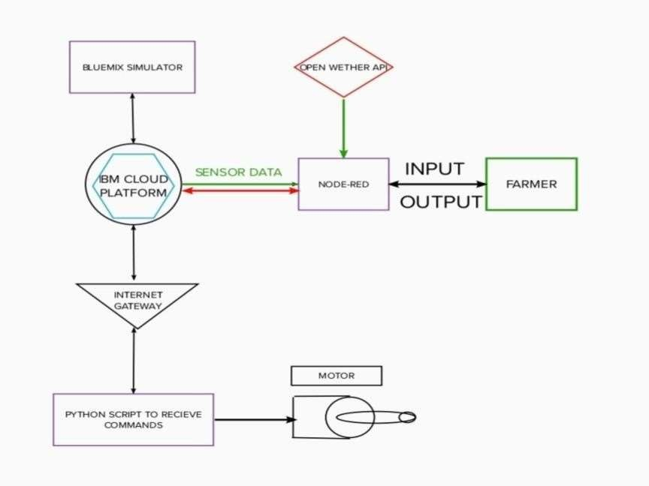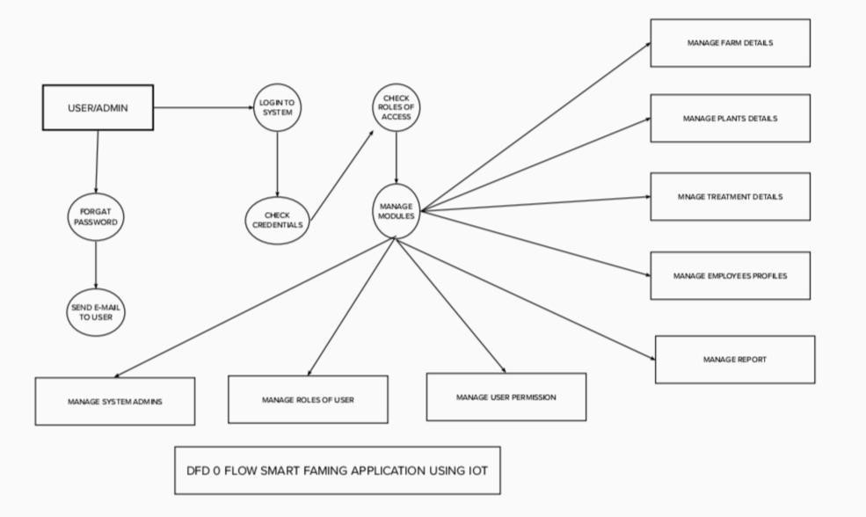

* The different soil parameters temperature, soil moistures and then humidity are sensed using different sensors and obtained value is stored in the IBM cloud.
* Arduino UNO is used as a processing Unit that process the data obtained from the sensors and whether data from the weather API.
* NODE-RED is used as a programming tool to write the hardware, software, and APIs. The MQTT protocol is followed for the communication.
* All the collected data are provided to the user through a mobile application that was developed using the MIT app inventor. The user could plan through an app, weather to water the crop or not depending upon the sensor values. By using the app they can remotely operate to the motor switch.

**User Stories**

Use the below template to list all the user stories for the product.

|  |  |  |  |  |  |  |
| --- | --- | --- | --- | --- | --- | --- |
| **User Type** | **Functional Requirement (Epic)** | **User**  **Story Number** | **User Story / Task** | **Acceptance criteria** | **Priority** | **Release** |
| Customer (Mobile user) | Registration | USN-1 | As a user, I can register for the application by entering my email, password, and confirming my password. | I can access my account / dashboard | High | Sprint-1 |
|  |  | USN-2 | As a user, I will receive confirmation email once I have registered for the application | I can receive confirmation email & click confirm | High | Sprint-1 |
|  |  | USN-3 | As a user, I can register for the application through Facebook | I can register & access the dashboard with Facebook Login | Low | Sprint-2 |
|  |  | USN-4 | As a user, I can register for the application through Gmail |  | Medium | Sprint-1 |
|  | Login | USN-5 | As a user, I can log into the application by entering email & password |  | High | Sprint-1 |
|  | Dashboard |  |  |  |  |  |
| Customer (Web user) |  |  |  |  |  |  |
| Customer Care Executive |  |  |  |  |  |  |
| Administrator |  |  |  |  |  |  |
|  |  |  |  |  |  |  |
|  |  |  |  |  |  |  |
|  |  |  |  |  |  |  |